Cryptozoology
Cryptozoology refers to the study or science of living things that are hidden or secret.
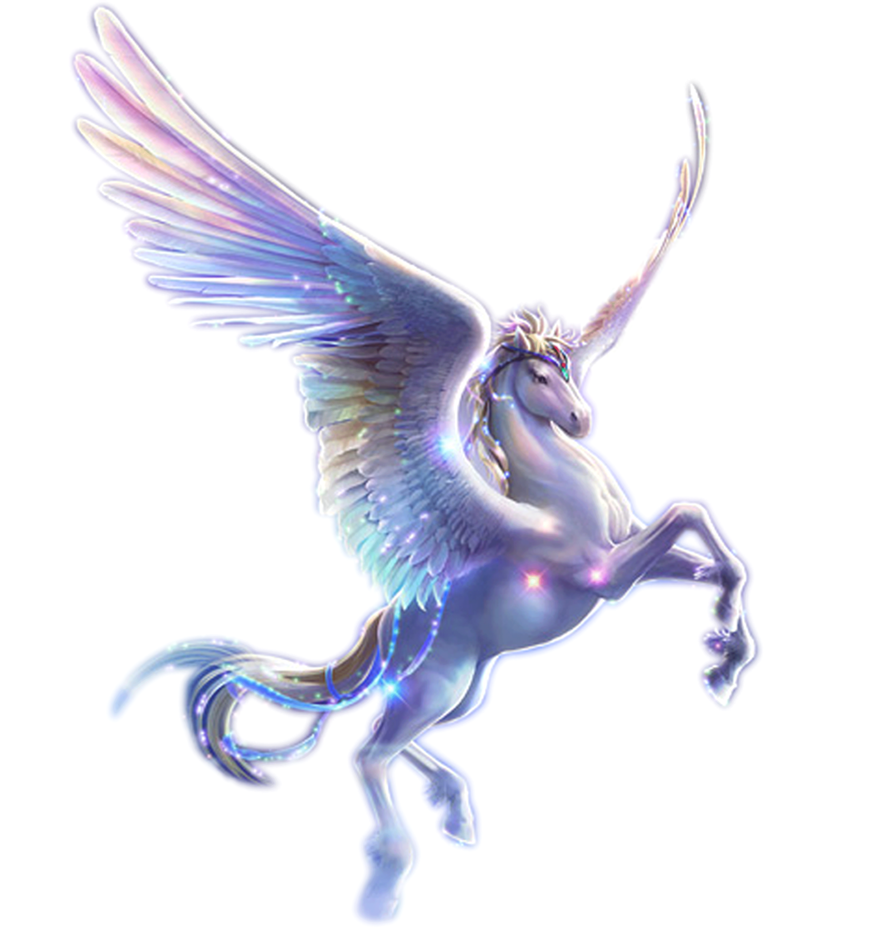
Creatures:
Usually, this just means any living thing that some people claim to be real yet many disbelieve. Some famous examples are Bigfoot, Yeti, Aliens, and Nessie (Loch Ness Monster). It also extends to the creatures that come from ancient legends such as Dragons, Satyrs, Centaurs, Phoenixes, Elves, Leprechauns, Dwarves, and the like.
Most of the time, this does not include creatures only found in recent publications (poems and books since the Renaissance) such as Jabberwocky (Lewis Carrol), Urgals (Christopher Paolini), and Orcs (J.R.R. Tolkien). These creatures are more commonly referred to as "fictional," and do not quite fall under the description of "hidden or secret."
Science:
These studies, although they attempt to fit in with modern science, are generally not scientific in nature, as the observation of such "Cryptids," if even possible, would generate disbelief and cause many to discredit the study. The scientific method requires observation of the subject, and since Cryptozoology does not include this in its reports (even if the observations are made and recorded in the nonpublicated material), it is considered among the authorities of the science world to be a pseudo-science, or false science, if they consider it a science at all! More often it is the case that cryptozoology is spurned from the scientific community altogether and labeled "speculative fiction."
Media:
Cryptozoology has inspired many novels and other forms of lexicographical art, most actually being speculative fiction and not at all helping cryptozoology to gain credit as a legitimate science. One such piece is a television show published by Cartoon Network beginning in 2008 called the Secret Saturdays, in which a boy, his mother, and his father work to protect cryptids from harm at the hands of a number of antagonistic characters. As can be expected from the station the show aired on, this is more about the action than anything else and uses cryptozoology only as a format for the action.

